Documentation for Sustainable Supply Chain Tables in Power BI

**Sustainable Supply Chain:**

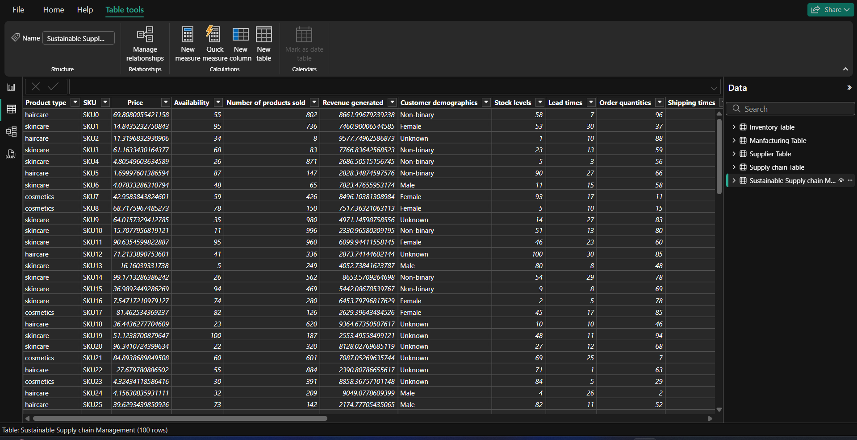

**1. Inventory Table:**

**Columns:**

1. **Product type**
2. **SKU**
3. **Availability**
4. **Number of products sold**
5. **Customer demographics**
6. **Stock levels**
7. **Lead times**
8. **Order quantities**
9. **Lead time**
10. **Revenue generated**

**Steps to Create:**

1. **Data Collection**: Collect data for product type, SKU, availability, number of products sold, customer demographics, stock levels, lead times, order quantities, and revenue generated from your supply chain database.
2. **Data Import**: Import the collected data into Power BI using the "Get Data" option.
3. **Data Transformation**: Use Power Query Editor to clean and transform the data as needed (e.g., removing duplicates, correcting data types).
4. **Table Creation**: Create a new table in Power BI named "Inventory Table" and load the transformed data.
5. **Data Visualization**: Use visuals like tables, charts, and graphs to represent the data effectively.

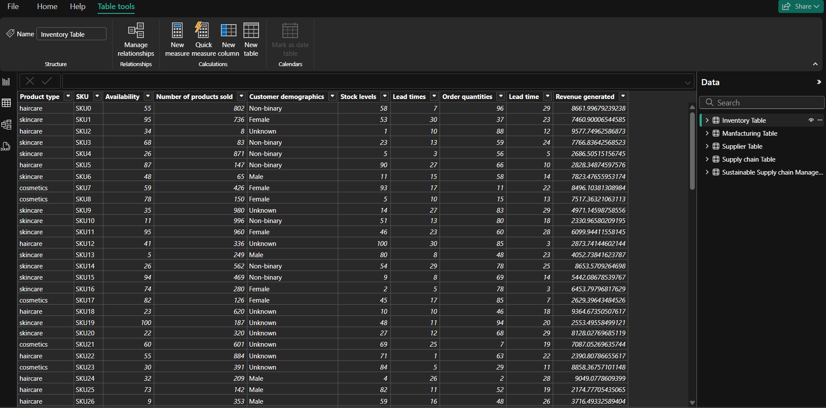

**2. Manufacturing Table:**

**Columns:**

1. **Product type**
2. **SKU**
3. **Production volumes**
4. **Manufacturing lead time**
5. **Manufacturing costs**
6. **Inspection results**
7. **Defect rates**

**Steps to Create:**

1. **Data Collection**: Collect data for product type, SKU, production volumes, manufacturing lead time, manufacturing costs, inspection results, and defect rates.
2. **Data Import**: Import the collected data into Power BI.
3. **Data Transformation**: Clean and transform the data using Power Query Editor.
4. **Table Creation**: Create a new table in Power BI named "Manufacturing Table" and load the data.
5. **Data Visualization**: Utilize visuals to represent manufacturing data and analyze key performance indicators.

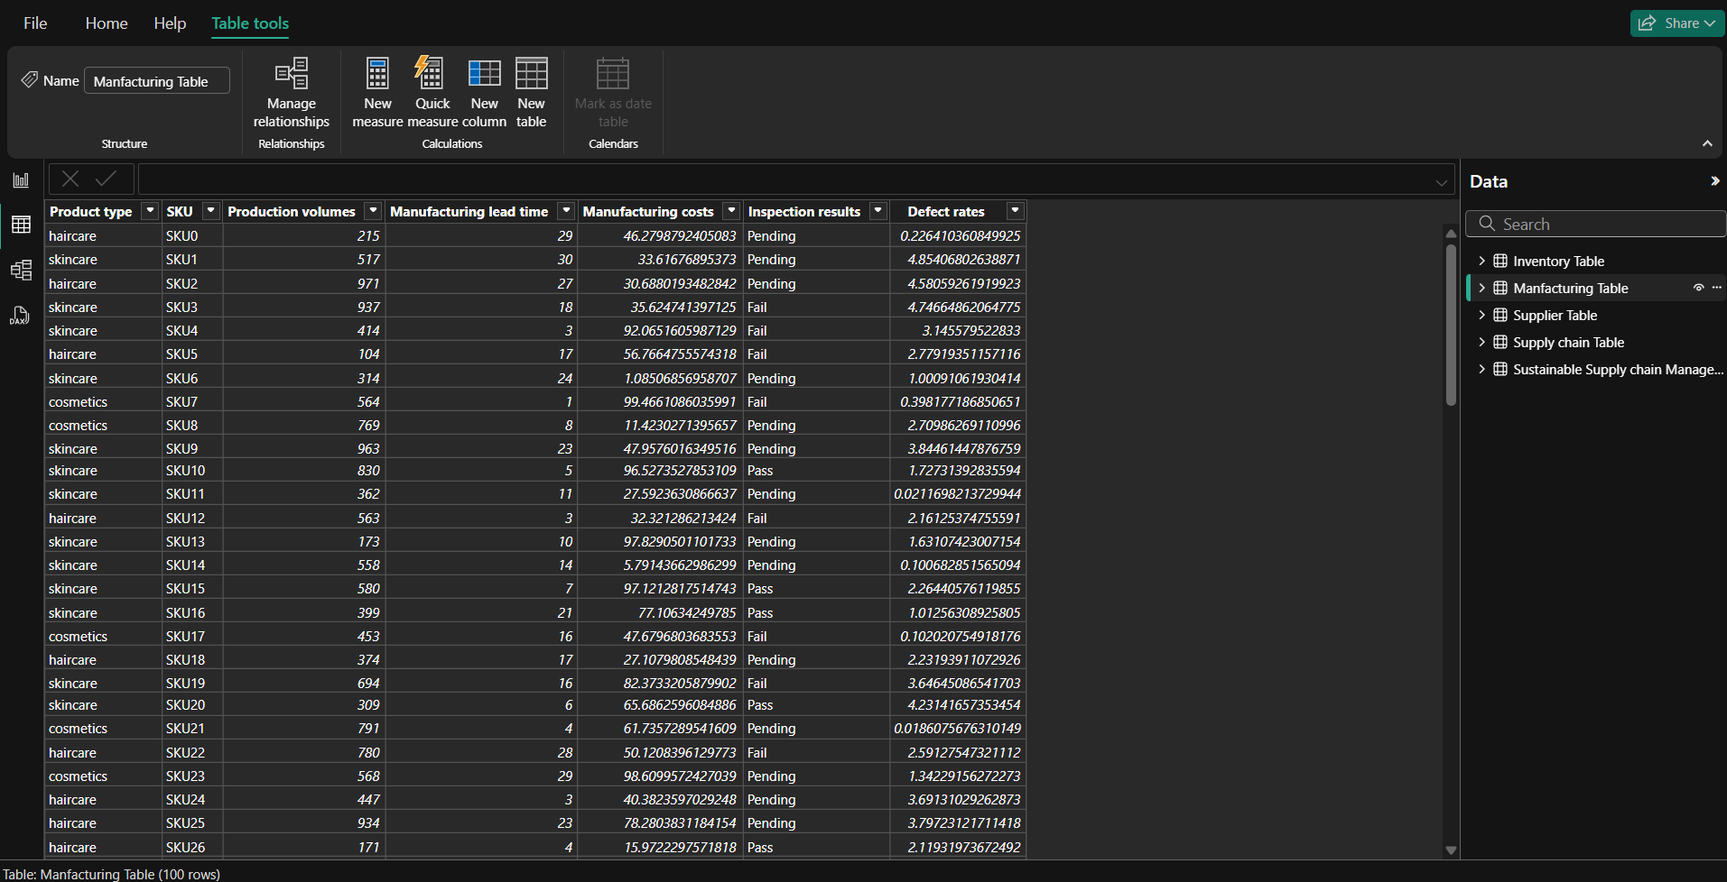

**3. Supplier Table:**

**Columns:**

1. **Supplier name**
2. **Location**
3. **Lead time**
4. **Transportation modes**
5. **Routes**

**Steps to Create:**

1. **Data Collection**: Gather data for supplier name, location, lead time, transportation modes, and routes.
2. **Data Import**: Import the data into Power BI.
3. **Data Transformation**: Use Power Query Editor to clean and transform the data.
4. **Table Creation**: Create a new table in Power BI named "Supplier Table" and load the data.
5. **Data Visualization**: Create visuals to analyze supplier performance and logistics.

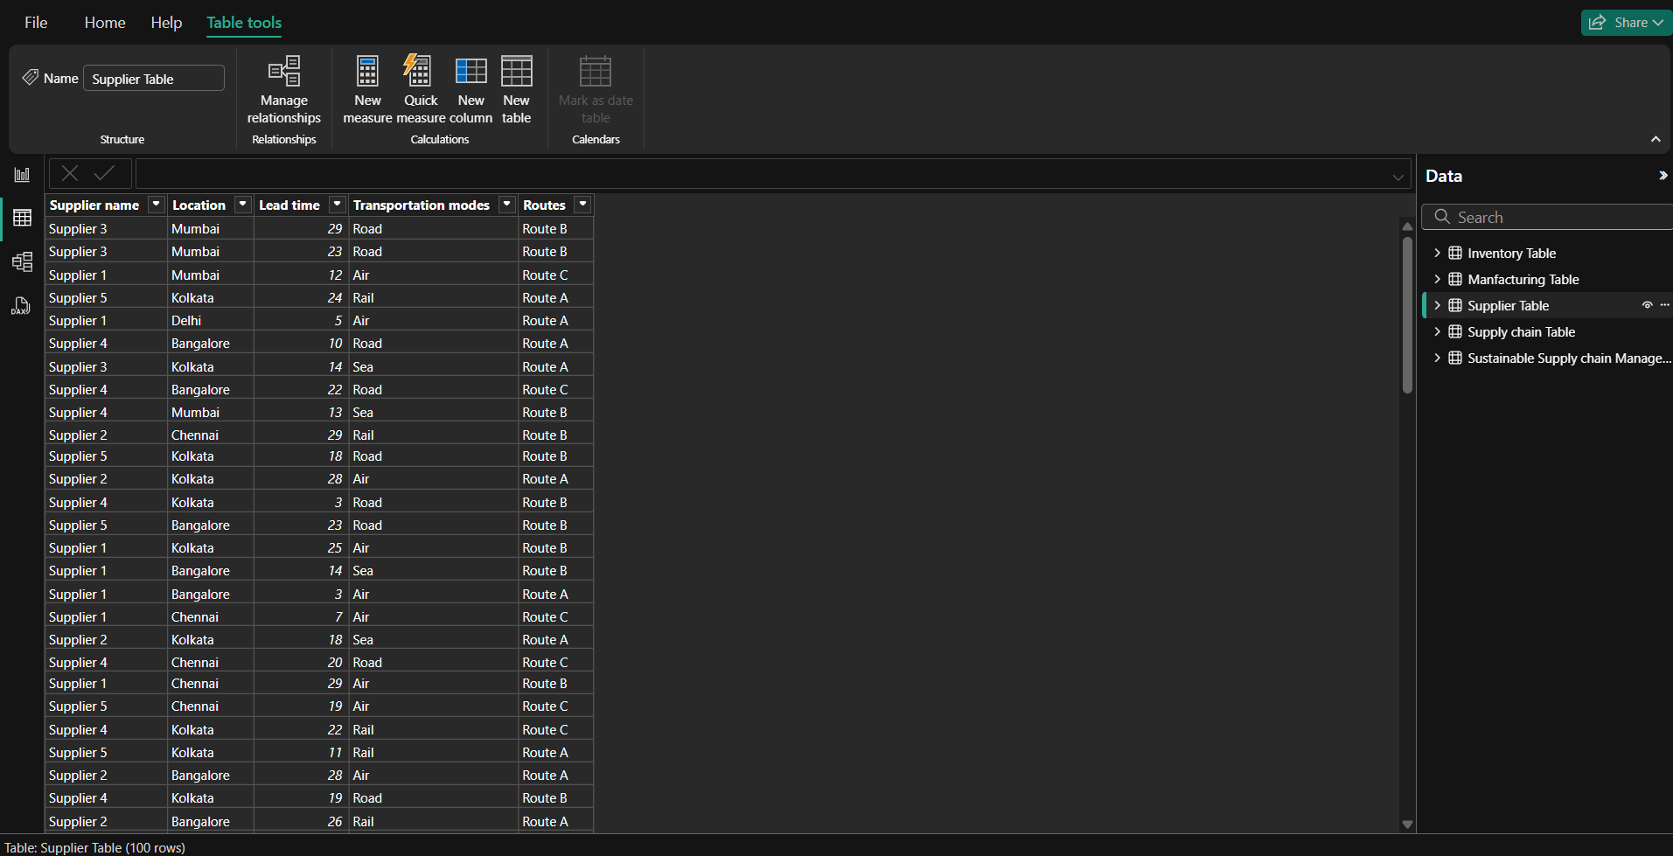

**4. Supply Chain Table:**

**Columns:**

1. **Product type**
2. **SKU**
3. **Price**
4. **Availability**
5. **Number of products sold**
6. **Revenue generated**
7. **Customer demographics**
8. **Stock levels**
9. **Lead times**
10. **Order quantities**
11. **Shipping times**
12. **Shipping carriers**
13. **Shipping costs**
14. **Supplier name**
15. **Location**
16. **Lead time**
17. **Transportation modes**
18. **Routes**

**Steps to Create:**

1. **Data Collection**: Collect comprehensive data for all supply chain aspects, including product type, SKU, price, availability, number of products sold, revenue generated, customer demographics, stock levels, lead times, order quantities, shipping times, shipping carriers, shipping costs, supplier name, location, lead time, transportation modes, and routes.
2. **Data Import**: Import the data into Power BI.
3. **Data Transformation**: Clean and transform the data using Power Query Editor.
4. **Table Creation**: Create a new table in Power BI named "Supply Chain Table" and load the data.
5. **Data Visualization**: Use a combination of visuals to analyze the entire supply chain, identify bottlenecks, and improve efficiency.

